GRAND TRAVERSE AUDUBON CLUB 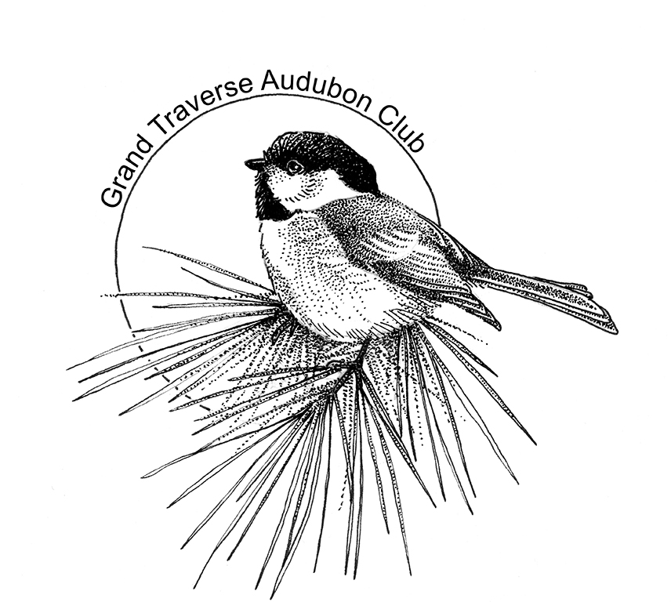

December 2017 www.grandtraverseaudubon.org

BIRD NOTES

SCHEDULE FOR WINTER 2017/ 2018

ANNUAL CHRISTMAS BIRD COUNTS

December 14 – Thursday – Antrim County
John Kreag, Coordinator – (231) 264-8969 (231) 360-0943
December 16 – Saturday – Grand Traverse County
Ed Moehle, Coordinator – (231) 947-8821
December 20 – Wednesday – Leelanau County
Nate Crane – (231) 499-5460 – e-mail address nmcrane@gmail.com

Contact any of the above CBC coordinators if you would like to participate. ALL interest and skill levels are welcome to join us. There are also counts happening in other areas such as Kalkaska, Benzie, Petoskey, etc.

December 14 – Regular meeting – Annual Photo Fest. Coordinator: Joe Brooks. Anyone wishing to share photos, video or other birding “show and tell,” contact Joe at 231 269-4343.
January 06 – Field Trip: Snowshoe Hike and Winter Wildlife. Leader Tom Ford
January 25 – Regular Meeting. Presentation by Heather Smith, our Grand Traverse Baykeeper, “Serving as the Eyes, Ears and Voice of the Natural Wonder that is Grand Traverse Bay.” For more on Baykeeper visit gtbay.org.
February 16, 17, 18 – Sault St. Marie. Meet 8:00 a.m. each morning in the Plaza Motel parking lot (906-653-1881). Other motels available nearby. Contact Leonard and Barb Graf to sign up. 231-946-5120 kestrel@charter.net or bluethroat@charter.net. See Barb’s article below.
February 22 – Meeting may be cancelled because of anticipated travel difficulties. Stay tuned.

The Soo in Winter!

Most people in Northern Michigan head south for the winter. They dream of places like Florida, Texas, and Arizona. These people have earned the nickname of “snowbirds.” But there is another group of northern Michigan people who head north in the winter; they go to the “Soo!”
Located in the Upper Peninsula of Michigan, the “Soo” is formally known as Sault Ste. Marie. It is the oldest city in Michigan, having been founded in 1668 by Father Jacques Marquette, and the third oldest city in the U.S. The 2000 census lists a population of 14,400 people for the city. It is believed that the word “sault” or “jump” refers to the 21-foot elevation difference between Lake Superior and Lake Huron.
This elevation difference is responsible for the need for the construction of the famous Soo Locks—a series of locks which allows ships to travel between Lake Huron and Lake Superior—which began as construction in the 1700s only to be destroyed in the War of 1812. Construction again began in the 1850s, was picked up by the federal government in the 1870s, and completed in 1968.
Near the St. Mary’s river and the Soo Locks you’ll find Lake Superior State University, which was founded in 1946 on a U.S. Army site, Ford Brady. LSSU has 14 buildings registered on the U.S. historic registry.
Since the early 1990s, groups of birders have “discovered” the Soo as an area to visit in the winter. My first visit to the Soo was cold, blowing and beautiful. At the historic power plant, I saw my first ever Gyrfalcon. The next year, a Northern Hawk Owl was sitting about 8 feet up in an aspen tree by the side of the road near the high school. The third year, while watching a Northern Shrike, a lady came out to the car and told us about this owl that was in a tree near her barn. The owl had been there quite a while and didn’t seem to be afraid of her or her horses. It was a small owl, with little dots on its forehead. As she welcomed us onto her property and through her barn, I was treated to another “lifer,” a Boreal Owl! On it went, each year I was adding another new species to my list. I was hooked on going to the Soo in Winter. In 1992 or 1993, there was an invasion of Great Gray Owls, on Sugar Island and on the mainland. My first Great Gray was about 10:00 in the morning; it was sitting in the top of a spruce tree in a small backyard. Another year, a Great Gray almost flew through the window of the van! Another year, I saw this bird in the distance. As we were setting up the scopes, the bird flew toward us and landed on a power pole just in front of the car.
We bird by caravan, spending a fair amount of time ion the warm cars. We’ve seen other wildlife, such as wolf or fox. Other birds that might be seen include Evening Grosbeak, White-winged Crossbill, Red Crossbill, Snow Bunting, Gray Jay, Ruffed Grouse, Cedar and/or Bohemian Waxwings, Ravens (or Cravens! – a cross between a Crow and Raven – when we weren’t certain.), White and Red-breasted Nuthatches, Common and Hoary Redpolls. This list goes on . . ..
But birding is not the only activity we do at the Soo. We also like to eat! Lunch is usually a quick affair. However, dinner is a time to get together and visit and share the day’s sightings. A few, after dinner, may decide to visit the local casino; but they still need to remember that we will be leaving early the next morning to locate the birds we didn’t find previously! Bring plenty of warm clothes and be ready for life birds, fun, and food. We meet on Friday & Saturday at 7:45 a.m. at the Plaza Motor Motel, across from the State Police Post to start our weekend. Come and join us for a weekend (February 16, 17, 18) at the Soo in Winter for a little history, birding, food, and fun. Call Barb or Leonard at (231) 946-5120 (H) or (231) 620-3024 (C) to let us know you’re coming and to find out if there is any updated information. Participants make their own motel reservations.
--Barb Graf

Winter Birding

Recent snowfall has transformed the gardens outside my windows into a living Christmas card. As daylight ascends on this winter wonderland a pair of Mourning Doves alight and begin foraging on the seed broadcast on the ground. Soon a handful of juncos join in. Their pink beaks are an exclamation point on a canvas of slate gray and white. They kick through pine needle mulch in search of white millet and sunflower chips.
At the top of a raspberry trellis I mounted a Tom Comfort built nest box. It is a work of art, and a favorite among my collection. House Wrens raised a brood in this lovely box this past summer. Today it's a winter roost for a Downy Woodpecker. He peeks out to find life in the backyard is getting busy. Black and gray squirrels scramble after peanuts in the shell scattered about. Our resident crow family competes for them as well. Swaying above the commotion on the ground a pair of cardinals feed from an ornate copper hanging feeder filled with hulled goodies.
I head to the coffee pot for a warm up and catch a flash of white wing lining as Mr. pileated puts on the brakes to touch down on the large pine. He surveys the scene before vaulting over to a suet feeder designed especially to accommodate big woodpeckers. He wastes little time stabbing chunks of suet with his long chisel tipped beak. I grab binocs for a closer look. A strikingly handsome bird he is, dressed in black, white, and red! And there's that beautiful yellow eye. Behind him a background of snow covered hemlock. This scene ignites the artistic portion of my brain and my right hand reaches for a paint brush that isn't there.
Later in the morning as I pull from the driveway goldfinches flush. They'd been feeding on coneflower heads left standing for winter wildlife. And another painting idea comes into focus.
--Tom Ford

Observations

We would like to have members submit brief observations of your birding adventures. We can include photos in the digital version of the newsletter. Submit stuff to dstring@ix.netcom.com.

Backyard Winter Birding
photos by Kim Stringer

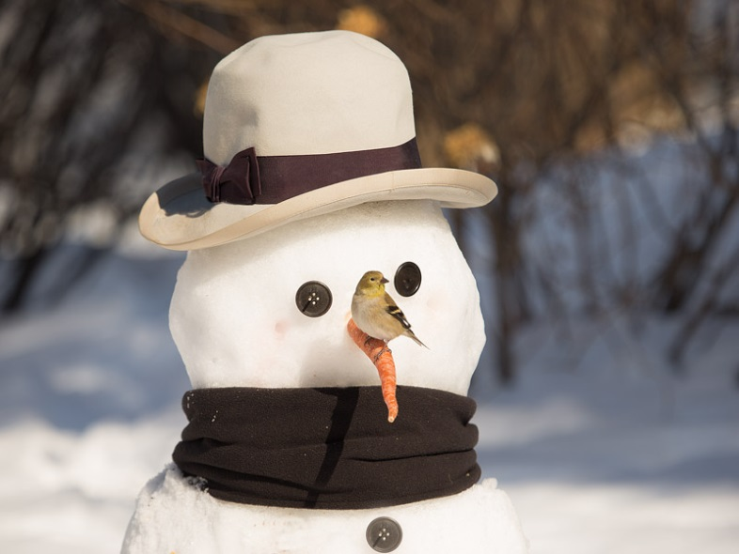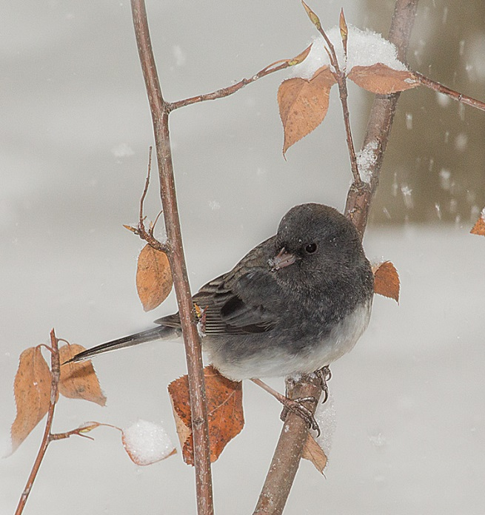

Happy Holidays!

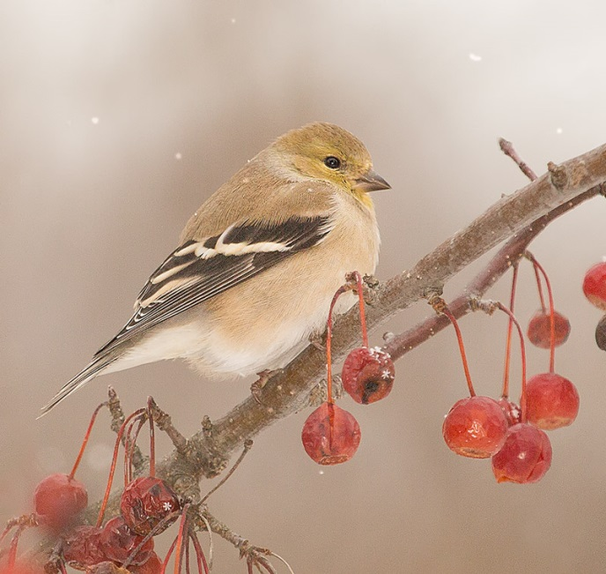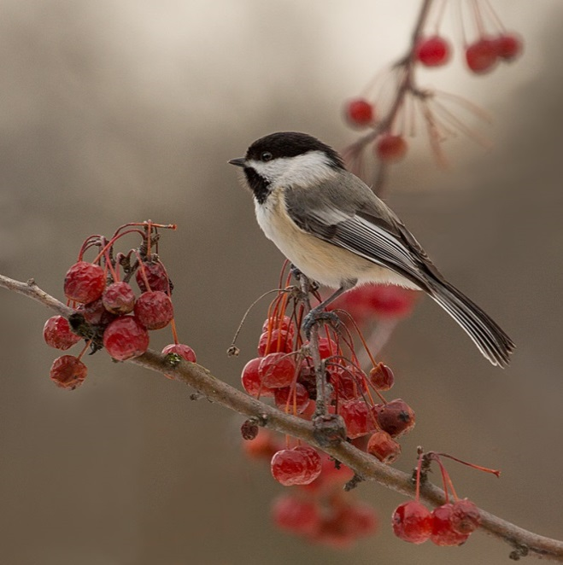

MEMBERSHIP FORM – 2018
(RENEWAL)

If you have not yet updated your membership for 2018, please find below a form and explanations of where to send your information.

Your Treasurer is Ed Kaminski. Please mail all dues to him at:
1498 Driftwood Dr.
Traverse City, MI 49686
Checks should be made payable to: Grand Traverse Audubon Club.(GTAC)

In order to continue receiving the Bird-alert and Club e-mails, membership’s dues must be up to date. All memberships run the Calendar Year

[ ] Family - $20 [ ] Individual - $15 [ ] Student - $8

Name: __________________________________________ Phone: ______________________
Please include Area Code
Name: __________________________________________ Cell Phone: ___________________

Address: _________________________________________

City: _________________________________ State: ______ Zip Code: _______________.

E-mail address: _________________________________________

__________________________________________

[ ] I would like to receive GT Audubon (club news) and Bird-alert (news of area bird sightings) VIA e-mail address.

[ ] Newsletter Mailed VIA U.S. Post office. I do not use the Internet.

[ ] Donation to Walter Hastings Memorial Environmental & Education Fund: $______________
(please note that donations to this fund are not tax deductible)

Enclosed is a check made out to Grand Traverse Audubon Club --- Mail To:

Ed Kaminski, Treasurer
1498 Driftwood Dr.
Traverse City, MI 49686

For questions and/or further information concerning membership dues, please email Ed at ebkaminski@msn.com

